WORKSHEET 1
Taguchi Analysis: RMS versus Tool diameter, Step over, Spindle speed, Feed rate

Response Table for Signal to Noise Ratios
Smaller is better
Level | Tool  diameter | Step over | Spindle  speed | Feed rate
1 | -19.44 | -19.45 | -19.45 | -19.45
2 | -19.44 | -19.45 | -19.45 | -19.45
3 | -19.45 | -19.45 | -19.45 | -19.45
4 | -19.45 | -19.45 | -19.45 | -19.45
Delta | 0.00 | 0.00 | 0.00 | 0.00
Rank | 1 | 4 | 2 | 3
Response Table for Means
Level | Tool  diameter | Step over | Spindle  speed | Feed rate
1 | 9.380 | 9.382 | 9.383 | 9.382
2 | 9.380 | 9.382 | 9.381 | 9.382
3 | 9.382 | 9.382 | 9.381 | 9.381
4 | 9.385 | 9.382 | 9.382 | 9.382
Delta | 0.005 | 0.001 | 0.002 | 0.001
Rank | 1 | 4 | 2 | 3
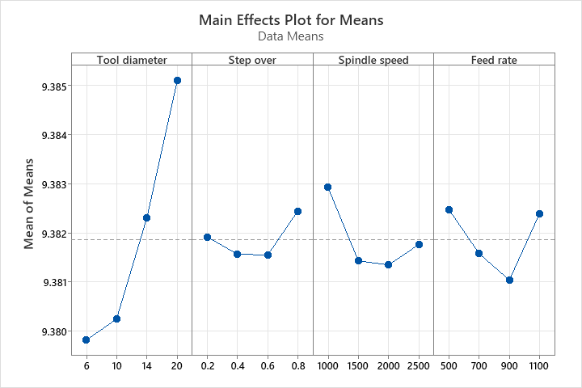
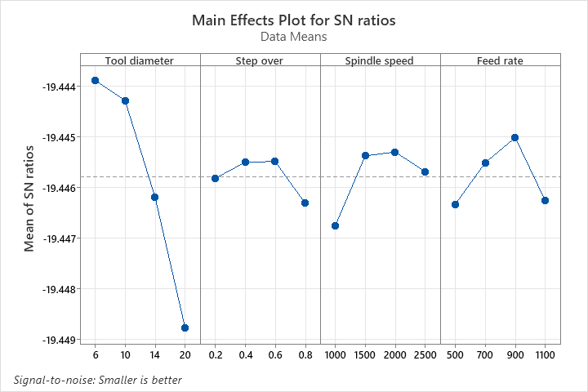

WORKSHEET 1
Regression Analysis: RMS versus Tool diameter, Step over, Spindle speed, Feed rate

Regression Equation
RMS | = | 9.37811 + 0.0003948 Tool diameter + 0.00079 Step over - 0.000000715 Spindle speed  - 0.00000039 Feed rate
Coefficients
Term | Coef | SE Coef | T-Value | P-Value | VIF
Constant | 9.37811 | 0.00285 | 3289.80 | 0.000
Tool diameter | 0.000395 | 0.000094 | 4.20 | 0.001 | 1.00
Step over | 0.00079 | 0.00217 | 0.36 | 0.724 | 1.00
Spindle speed | -0.000001 | 0.000001 | -0.82 | 0.428 | 1.00
Feed rate | -0.000000 | 0.000002 | -0.18 | 0.860 | 1.00
Model Summary
S | R-sq | R-sq(adj) | R-sq(pred)
0.0019430 | 62.73% | 49.18% | 0.00%
Analysis of Variance
Source | DF | Adj SS | Adj MS | F-Value | P-Value
Regression | 4 | 0.000070 | 0.000017 | 4.63 | 0.020
Tool diameter | 1 | 0.000067 | 0.000067 | 17.67 | 0.001
Step over | 1 | 0.000000 | 0.000000 | 0.13 | 0.724
Spindle speed | 1 | 0.000003 | 0.000003 | 0.68 | 0.428
Feed rate | 1 | 0.000000 | 0.000000 | 0.03 | 0.860
Error | 11 | 0.000042 | 0.000004
Total | 15 | 0.000111
Fits and Diagnostics for Unusual Observations
Obs | RMS | Fit | Resid | Std Resid
1 | 9.38375 | 9.37972 | 0.00403 | 2.93 | R
R Large residual
